Project Development Phase
Model Performance Test

Date | 03 Oct 2026
Team ID | Team 12
Project Name | Streamlining IT Procurement: Automating Standard Laptop Orders with Flow Designer
Maximum Marks

Model Performance Testing:
Project team shall fill the following information in model performance testing template.
S.No. | Parameter | Values | Screenshot
 | Model Summary | ServiceNow Flow Designer automation for standard laptop procurement using Request Form, Manager Approval, Inventory Check, Procurement, Status Update and Notifications. | 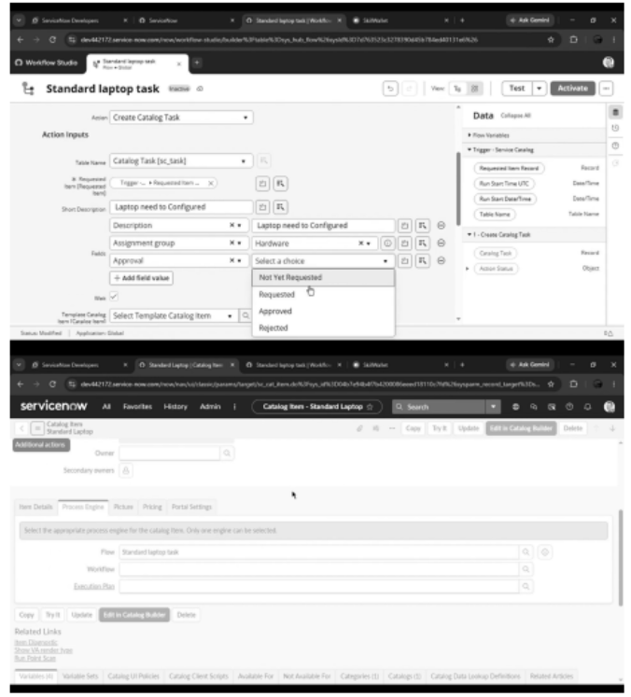
 | Accuracy | Request Submission – Successful  Manager Approval – Successful  Inventory Check – Successful  Procurement/Allocation – Successful  Status Update – Successful  Notification – Successful | - 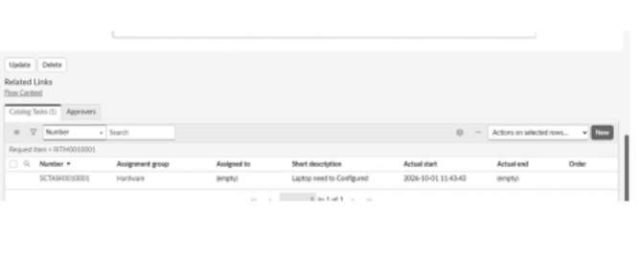
3. | Confidence Score (Only Yolo Projects) | Approved + Laptop Available – Laptop allocation is initiated.  Approved + Laptop Unavailable – Procurement request is created.  Request Rejected – Request is stopped and employee is notified. | -

